7.36: From Eq. (7.19), 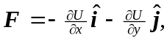 since U has no z-dependence. 